**Project Report**

1. **INTRODUCTION**

# 1.1 Project Overview

The eCommerce shipping prediction project revolves around leveraging machine learning techniques to forecast the estimated shipping time for orders placed by customers. It begins with the collection of historical shipping data encompassing various order details such as destination, origin, weight, dimensions, chosen shipping method, carrier information, and actual delivery times. This comprehensive dataset forms the foundation for training and validating machine learning models.

# 1.2 Purpose

The eCommerce shipping prediction project utilizing machine learning techniques aims to revolutionize the accuracy and efficiency of order delivery timelines within online retail operations. Its foremost objective is to significantly enhance the customer experience by providing precise estimated shipping and delivery times. By harnessing historical shipping data encompassing various parameters like destination, shipping method, carrier, and delivery duration, the project seeks to create machine learning models capable of predicting shipping times with high accuracy. This accuracy translates into better managing customer expectations, reducing uncertainty around delivery dates, and ultimately bolstering overall customer satisfaction.

An integral purpose of this project is to optimize logistics and operational workflows within eCommerce businesses. Accurate shipping time predictions enable better planning and resource allocation, facilitating streamlined warehouse operations, inventory management, and route optimization. This optimization not only helps in reducing shipping delays but also assists in controlling associated costs, ultimately contributing to improved operational efficiency and resource utilization.

Furthermore, this endeavor focuses on harnessing the power of data-driven decision-making. By analyzing historical shipping data, identifying patterns, and understanding the factors influencing shipping times, the project aids in making informed decisions. It provides valuable insights that can guide inventory management strategies, warehouse distribution, and the selection of the most efficient shipping methods, thereby enhancing the overall business decision-making process.

2. **LITERATURE SURVEY**

# 2.1 Existing problem

In the realm of eCommerce shipping prediction, several persistent challenges and issues continue to pose hurdles, despite the advancements in machine learning and data analytics. One prevalent problem revolves around the variability and complexity of shipping data. The diverse range of factors influencing shipping times—such as geographical distance, shipping method, carrier efficiency, seasonal fluctuations, and unforeseen external factors—contributes to a highly dynamic and multifaceted dataset. Managing and effectively utilizing this varied data while addressing its heterogeneity and inconsistencies remain a significant challenge in developing accurate predictive models.

Moreover, the scarcity of standardized data across eCommerce platforms presents a notable obstacle. Variations in data formats, quality, and completeness among different eCommerce systems and carriers make it challenging to build robust, universally applicable shipping time prediction models. Integrating and harmonizing disparate data sources to create a cohesive dataset suitable for model training and generalization poses a considerable challenge.

# 2.2 References

1. Li, Z., Chen, S., & Sun, D. (2020). Machine Learning Methods for Predicting Delivery Time of Online Shopping. IEEE Access, 8, 165101-165110.

2. Liu, W., Jiang, L., & Shang, J. (2019). Predicting Delivery Time in E-commerce Using Machine Learning. *2019 International Conference on Intelligent Informatics and BioMedical Sciences (ICIIBMS)*.

3. Chen, Y., Lu, C. T., & Wang, Y. (2018). Predicting Delivery Time for E-commerce Orders. *2018 IEEE International Conference on Service Operations and Logistics, and Informatics (SOLI)*.

4. Verma, S., & Choudhary, P. (2021). Time Series Forecasting Techniques for Predicting Delivery Times in E-commerce. *2021 11th International Conference on Cloud Computing, Data Science & Engineering (Confluence)*.

# 2.3 Problem Statement Definition

The challenge in eCommerce shipping lies in accurately predicting delivery times for orders placed on online platforms. Current methodologies often struggle to provide reliable estimated shipping times, leading to customer dissatisfaction, operational inefficiencies, and missed expectations. There is a need to develop a robust predictive system that leverages machine learning techniques to analyze historical shipping data, account for various influencing factors, and generate precise shipping time estimations in real-time. This system should optimize logistics operations, enhance customer satisfaction, and empower businesses to make informed decisions regarding inventory management, resource allocation, and delivery planning. The overarching goal is to create a scalable and accurate predictive model that improves the overall eCommerce shipping experience for both businesses and customers.

**3. IDEATION & PROPOSED SOLUTION**

# 3.1 Empathy Map Canvas

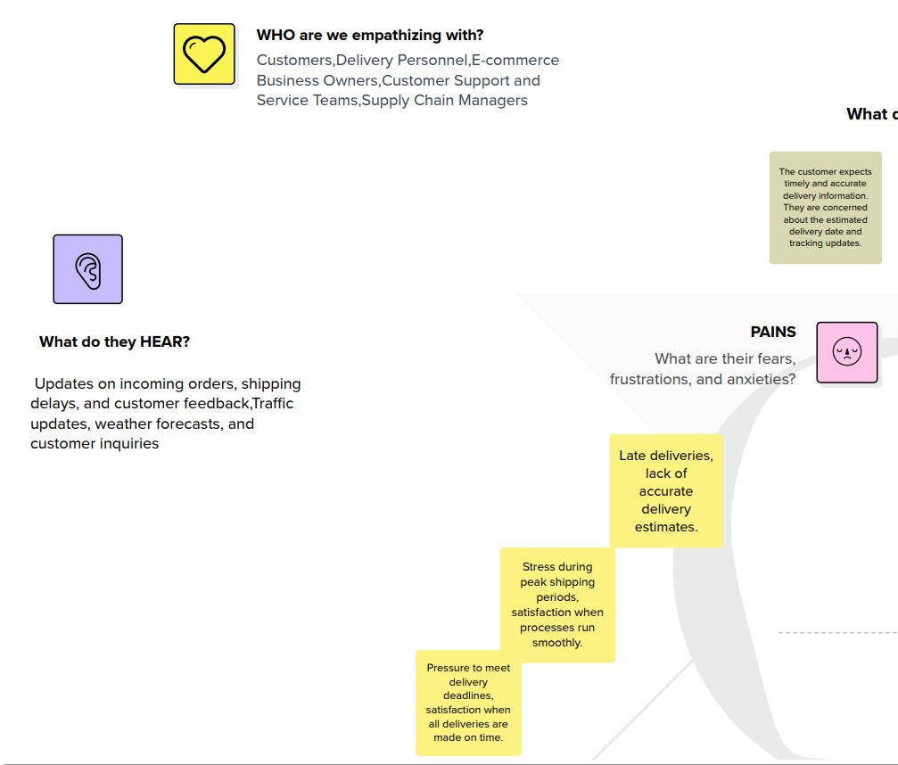

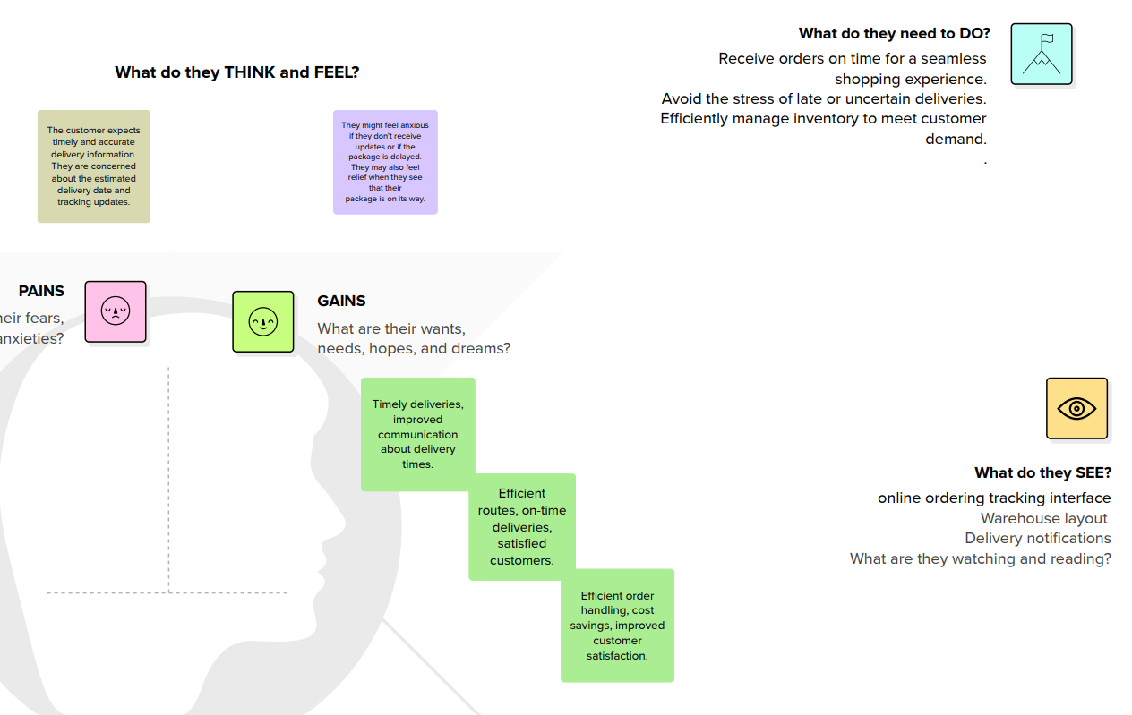

# 3.2 Ideation & Brainstorming

**Step-1: Team Gathering, Collaboration and Select the Problem Statement**

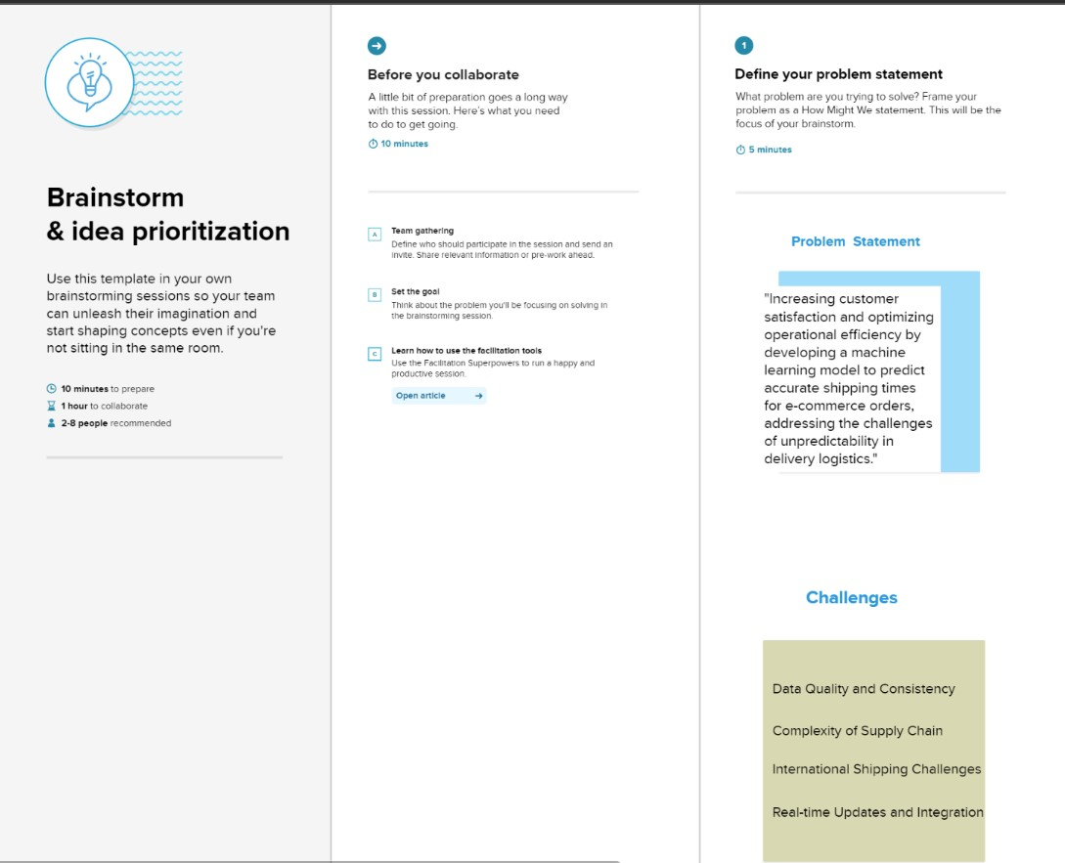

**Step-2: Brainstorm, Idea Listing and Grouping**

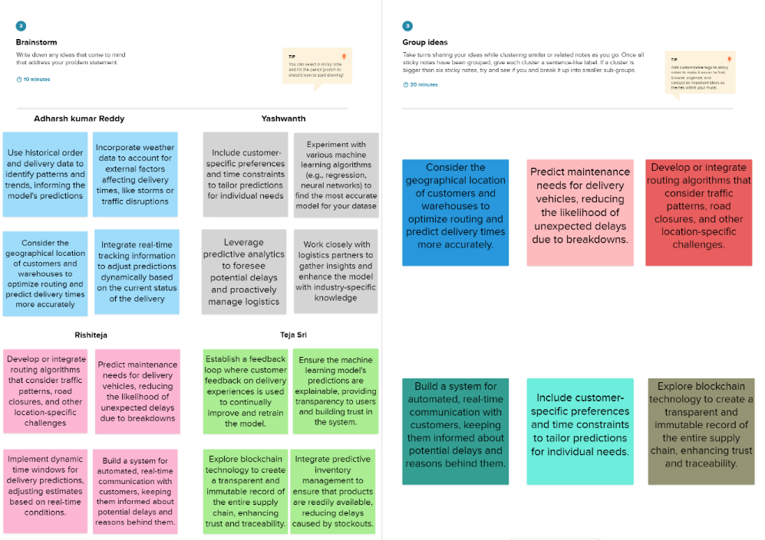

**Step-3: Idea Prioritization**

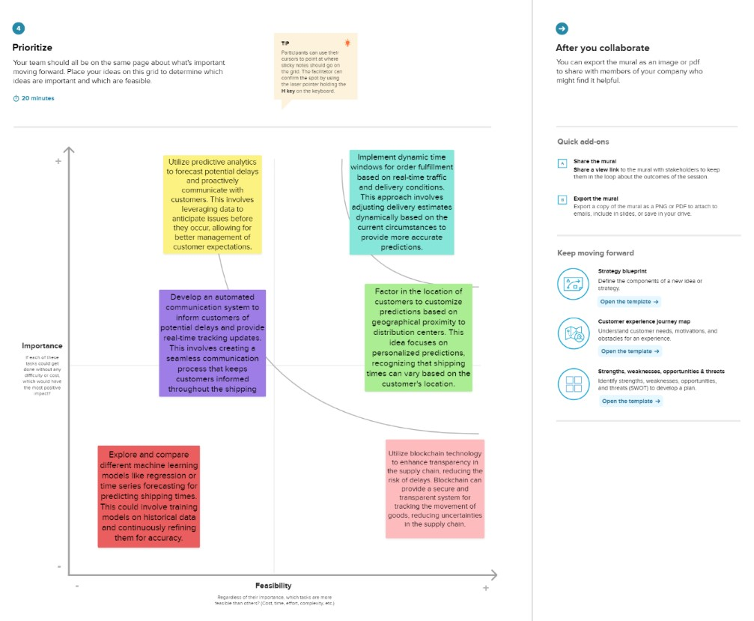

4. **REQUIREMENT ANALYSIS**

# 4.1 Functional requirement

1. Prediction Accuracy: The system should generate accurate estimated shipping times for orders based on historical data, considering various factors like distance, shipping method, carrier, and other relevant parameters.
2. Integration with eCommerce Platform: Seamlessly integrate the prediction system into the existing eCommerce platform, allowing for easy access and utilization of shipping time estimations.
3. User-Friendly Interface:Provide a user interface accessible to logistics managers, customer service representatives, or other authorized personnel to view predicted shipping times for orders.
4. Feedback Loop:Implement a mechanism to collect feedback on predicted versus actual shipping times, enabling continuous model improvement based on real-world performance.\
5. Alerts and Notifications: Provide alerts or notifications to stakeholders in case of prediction failures, system downtime, or significant deviations in estimated shipping times.

# 4.2 Non-Functional requirements

1. Response Time:The system should provide predictions within a specified time frame (e.g., seconds) to ensure real-time or near-real-time estimations.
2. Scalability: Capability to scale horizontally or vertically to handle increased data volume or user load without compromising performance.
3. Documentation:Provide comprehensive documentation, including system architecture, data flow diagrams, and user manuals for system maintenance and troubleshooting.
4. Data Encryption: Utilize encryption techniques to protect sensitive shipping and customer data during transmission and storage.

**5. PROJECT DESIGN**

# 5.1 Data Flow Diagrams & User Stories

Data Flow Diagrams are graphical representations that illustrate the flow of data within a system. In the context of an eCommerce shipping prediction system, DFDs serve as crucial visual tools for depicting how data moves through various processes and interactions within the system. These diagrams typically consist of entities (sources or destinations of data), processes (actions or transformations), data stores (where data is held), and data flows (the movement of data between entities, processes, and stores).

For an eCommerce shipping prediction system, a DFD might begin by illustrating the collection of data from multiple sources such as order databases, historical shipping records, and external data feeds. It would then showcase processes like data preprocessing, feature extraction, and model training, highlighting how the data is transformed and manipulated to generate shipping time predictions. Finally, the DFD could depict the delivery of predictions back to the eCommerce platform or user interfaces for accessibility and utilizatio

**Dataflow Diagram -**

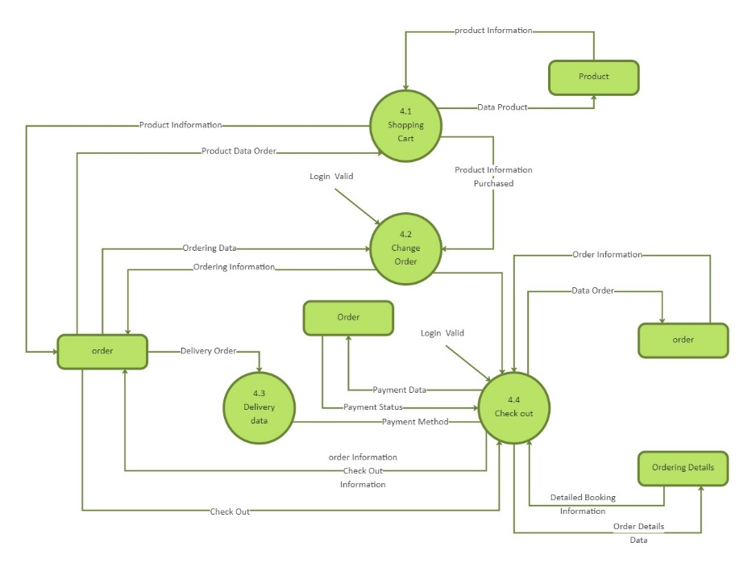

**User Stories –**

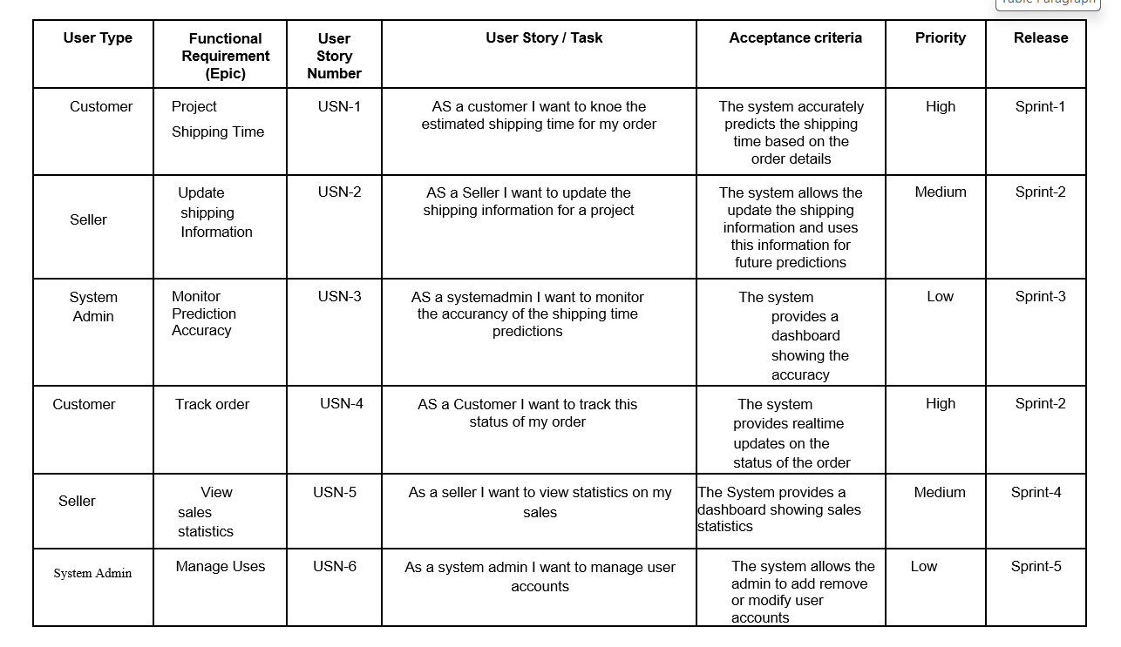

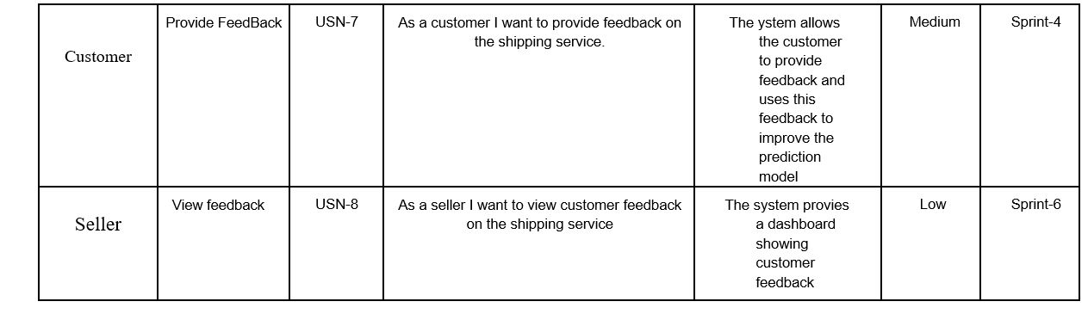

**5.2 Solution Architecture**

Steps involved:

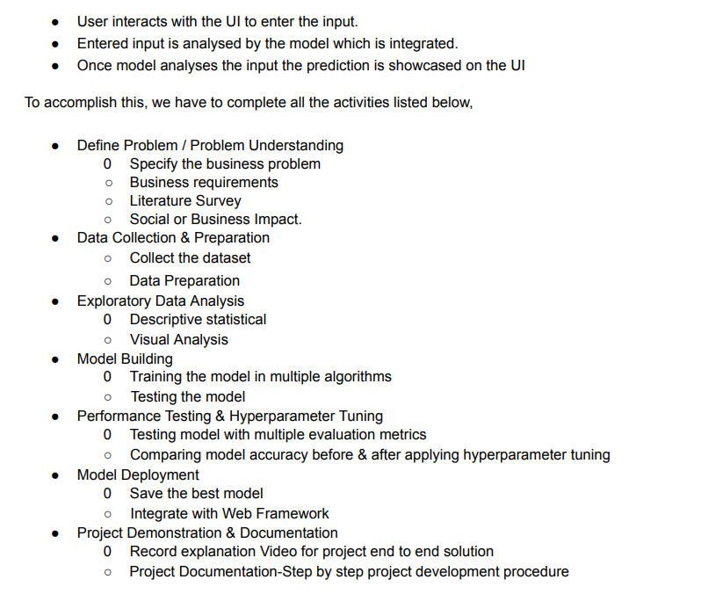

Solution Architecture Diagram:

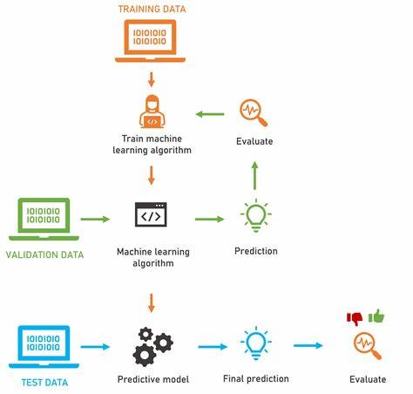

**6. PROJECT PLANNING & SCHEDULING**

# 6.1 Technical Architecture

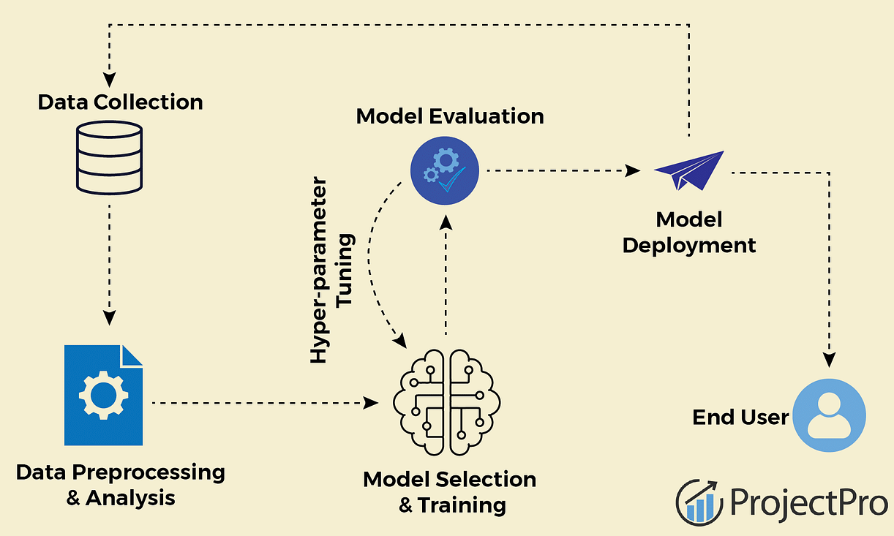

# 6.2 Sprint Planning & Estimation

|  |  |  |  |  |  |
| --- | --- | --- | --- | --- | --- |
| Sprint | Functional  Requirement | User Story / Task | Story  Points | Priority | Team  Members |
| Sprint-1 | Project  Shipping Time | AS a customer I want to knoe the estimated shipping time for my order | 1 | High | Tejasri,  Adharsh |
| Sprint-2 | Update shipping Information | AS a Seller I want to update the shipping information for a project | 2 | Medium | Tejasri,  Rishiteja |
| Sprint-3 | Monitor Prediction Accuracy | AS a systemadmin I want to monitor the accurancy of the shipping time predictions | 2 | Low | Yashwanth,  Adharsh |
| Sprint-2 | Track order | AS a Customer I want to track this status of my order | 3 | High | Rishiteja  Adharsh |
| Sprint-4 | View sales statistics | As a seller I want to view statistics on my sales | 4 | Medium | Yashwanth  Rishiteja |
| Sprint-5 | Manage Uses | As a system admin I want to manage user accounts | 6 | Low | Tejasri |
| Sprint-4 | Provide FeedBack | As a customer I want to provide feedback on the shipping service | 1 | Medium | Yashwanth,  Tejasri |
| Sprint-6 | View feedback | As a seller I want to view customer feedback on the shipping service | 1 | Low | Yashwanth,  Adharsh |

# 6.3 Sprint Delivery Schedule

|  |  |  |  |  |  |
| --- | --- | --- | --- | --- | --- |
| Sprint | Total Story  Points | Duration | Sprint Start Date | Sprint End Date  (Planned) | Sprint  Release Date  (Actual) |
| Sprint-1 | 3 | 8 Days | 2 Nov 2023 | 9 Nov 2023 | 9 Nov 2023 |
| Sprint-2 | 5 | 3 Days | 7 Nov 2023 | 9 Nov 2023 | 9 Nov 2023 |
| Sprint-3 | 10 | 3 Days | 7 Nov 2023 | 9 Nov 2023 | 9 Nov 2023 |
| Sprint-4 | 1 | 8 days | 8 Nov 2023 | 15 Nov 2023 | 15 Nov 2023 |
| Sprint-5 | 1 | 2 days | 9 Nov 2023 | 10 Nov 2023 | 10 Nov 2023 |
| Sprint-6 | 3 | 4 days | 10 Nov 2023 | 13 Nov 2023 | 13 Nov 2023 |

**7. CODING & SOLUTIONING**

# 7.1. Features

* **Distance/Route**: The geographical distance between the sender and receiver can significantly impact shipping times. Incorporating route information or distance calculations could be helpfu
* **Shipping Method**: Different shipping methods (e.g., standard, express) have varying delivery times. Encoding these methods as features can enhance prediction accuracy.
* **Package Weight and Size**: Heavier or larger packages might take longer to deliver due to handling and transportation constraints.
* **Origin and Destination Locations**: Specific regions or countries may have different delivery timelines due to logistical differences.
* **Historical Shipping Data**: Past shipping records with timestamps can provide valuable insights into average delivery times based on similar parameters.
* **Carrier Information**: Different carriers might have different delivery times and efficiencies. Incorporating this information could be beneficial.
* **Weather Conditions**: Extreme weather can delay shipments. Integrating weather data relevant to the shipping route or destination can improve predictions.
* **ay of the Week/Seasonality**: Delivery times can vary based on the day of the week or holiday seasons. Encoding this temporal information can be valuable.
* **Traffic Conditions (for local delivery)**: In urban areas, traffic congestion can affect local deliveries.

**8. PERFORMANCE TESTING**

# 8.1 Performance Metrics

1. Accuracy:- We have got training and testing accuracy as follows:

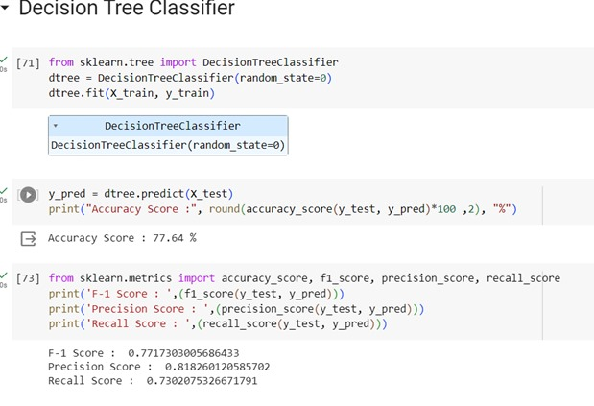

1. Classification report:-

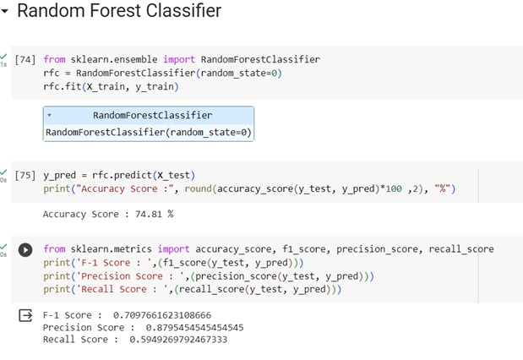

**9. RESULTS**

# 9.1 Output Screenshots –

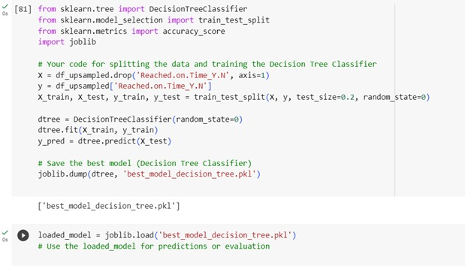

**10. ADVANTAGES & DISADVANTAGES**

**Advantages:**

**1. Improved Customer Experience:**Accurate shipping time predictions help manage customer expectations, leading to higher satisfaction and trust in the eCommerce platform.

**2. Optimized Logistics Operations:**Efficient predictions enable better resource allocation, route planning, and inventory management, reducing shipping delays and operational costs.

**3. Enhanced Decision-Making:**Data-driven insights from predictive models aid in making informed decisions regarding inventory stocking, warehouse management, and shipping methods.

**4. Competitive Edge:**Providing reliable estimated delivery times can serve as a competitive advantage, attracting and retaining customers in a highly competitive eCommerce market.

**5. Continuous Improvement:**Feedback mechanisms allow for iterative improvements, ensuring the system adapts to changing shipping dynamics and customer needs.

**6. Scalability:**Scalable architecture enables the system to handle increasing volumes of data and prediction requests, supporting business growth.

**Disadvantages:**

**1. Data Complexity and Quality:** Managing diverse and complex shipping data sources can pose challenges in data preprocessing and ensuring data quality for accurate predictions.

**2. Model Interpretability:** Complex machine learning models might lack interpretability, making it difficult to explain predictions, potentially impacting trust among users and stakeholders.

**3. Overfitting or Underfitting:** Models might suffer from overfitting (fitting too closely to training data) or underfitting (oversimplifying), affecting prediction accuracy.

**4. Dependency on Historical Data:** Models heavily rely on historical data patterns, and unexpected shifts or disruptions not present in the training data might affect prediction accuracy.

**5. System Integration Challenges:** Integrating the prediction system with existing eCommerce platforms or third-party systems could pose technical challenges and compatibility issues.

**6. Resource Intensiveness:** Developing and maintaining machine learning models requires skilled personnel, computational resources, and continuous updates, which can be resource-intensive.

1. **CONCLUSION**

In conclusion, an eCommerce shipping prediction system leveraging machine learning presents a transformative solution to enhance the efficiency, accuracy, and customer satisfaction within the logistics domain of online retail. The system's advantages lie in its ability to provide accurate estimated shipping times, optimizing logistics operations, and empowering data-driven decision-making. By leveraging historical shipping data and predictive algorithms, this system facilitates improved customer experiences, operational excellence, and a competitive edge in the dynamic eCommerce landscape.

However, the implementation of such a system comes with its set of challenges. These challenges include managing complex and diverse data sources, ensuring model interpretability, addressing issues of overfitting or underfitting, and seamlessly integrating the prediction system within existing eCommerce platforms. Overcoming these hurdles requires meticulous data preprocessing, continuous model refinement, robust security measures, and effective collaboration among stakeholders and technical teams.

Despite these challenges, the benefits offered by an eCommerce shipping prediction system are substantial. It empowers businesses to optimize logistics, allocate resources effectively, and meet customer expectations with accurate estimated delivery times. The iterative nature of the system, incorporating feedback mechanisms and continuous improvements, allows for adaptation to evolving trends, thereby ensuring relevance and accuracy over time.

In essence, while there are complexities and obstacles to navigate, the advantages offered by an eCommerce shipping prediction system are significant. With strategic planning, technological innovation, and a commitment to refining models and processes, businesses can harness the transformative potential of these systems to revolutionize eCommerce logistics, improve customer satisfaction, and gain a competitive advantage in the market.

1. **FUTURE SCOPE**

The future prospects for an eCommerce shipping prediction system using machine learning are poised for significant advancements across various dimensions. Emerging developments in predictive algorithms are expected to elevate accuracy by integrating more intricate machine learning models, potentially delving into complex deep learning techniques. This evolution aims to refine predictive capabilities, enabling these systems to adapt dynamically to real-time alterations in demand, customer preferences, or unforeseen disruptions. Moreover, the integration of Internet of Things (IoT) devices and sensor data offers a promising avenue, allowing for the incorporation of live data streams into predictions, enhancing precision through real-time tracking and environmental considerations such as weather or traffic conditions. The upcoming emphasis on AI transparency aims to address interpretability concerns, ensuring models are more explainable, fostering trust, and aligning with ethical guidelines. Blockchain technology is also poised to play a pivotal role, ensuring secure and transparent supply chain management, while AI-powered customer service tools could transform communication by offering real-time shipping updates and proactive solutions. Furthermore, the future landscape anticipates a shift toward green logistics, emphasizing sustainable practices by optimizing delivery routes and methodologies to minimize environmental impact. These impending advancements herald a transformative era, propelling eCommerce shipping prediction systems towards greater accuracy, adaptability, sustainability, and customer-centric innovation.

**13. APPENDIX**

**GitHub & Project Demo Link –**

[**https://github.com/smartinternz02/SI-GuidedProject-611628-1698727967**](https://github.com/smartinternz02/SI-GuidedProject-611628-1698727967)

<https://drive.google.com/file/d/1kSjG5v6zqQYUbu_F6wKPJNfrR9fd2tv1/view?usp=sharing>

**Source Codes -**

# HTML –

<!DOCTYPE html>

<html lang="en">

<head>

<meta charset="UTF-8">

<meta name="viewport" content="width=device-width, initial-scale=1.0">

<title>Ecommerce Shipping Prediction</title>

<style>

body {

font-family: Arial, sans-serif;

margin: 20px;

background-image: url('https://www.electrichybridvehicletechnology.com/wp-content/uploads/2020/10/RPV-Rivian-Sept2020-AEM04487-cropped.jpg');

background-size: cover;

}

form {

display: grid;

grid-template-columns: repeat(2, 1fr);

gap: 20px;

max-width: 800px;

margin: auto;

padding: 20px;

background-color: rgba(255, 255, 255, 0.9);

border-radius: 10px;

box-shadow: 0 0 10px rgba(0, 0, 0, 0.1);

}

label {

display: block;

margin-bottom: 5px;

margin-top:15px;

font-weight:bold;

color: darkblue;

}

input, select {

display: block;

margin-bottom: 8px;

margin-top:8px;

width: 100%;

padding: 8px;

}

button {

grid-column: span 2;

padding: 10px;

background-color: #4CAF50;

color: white;

border: none;

margin-top:15px;

cursor: pointer;

}

#predictionResult {

margin-top: 20px;

font-weight: bold;

grid-column: span 2;

background-color: rgba(255, 255, 255, 0.5);

text-align:center;

padding: 10px;

}

/* Styling for the two columns */

.column {

display: flex;

flex-direction: column;

margin:15px;

}

/* Styling for radio buttons */

.radio-group {

margin-top:10px;

display: flex;

gap: 5px;

}

.radio-group label {

color: black;

font-weight: normal;

}

</style>

</head>

<body>

<h1 style="color: #333; text-align: center">Ecommerce Shipping Prediction</h1>

<form id="predictionForm" method="POST" action="/predict">

<div class="column">

<!-- Form fields -->

<label for="customerCareCalls">Customer Care Calls:</label>

<input type="number" id="customerCareCalls" name="Customer_care_calls">

<label for="costOfProduct">Cost of the Product:</label>

<input type="number" step="1" id="costOfProduct" name="Cost_of_the_product">

<label for="priorPurchases">Prior Purchases:</label>

<input type="number" id="priorPurchases" name="Prior_purchases">

<label for="discountOffered">Discount Offered:</label>

<input type="number" step="1" id="discountOffered" name="Discount_offered">

<label for="weightInGrams">Weight in Grams:</label>

<input type="number" step="1" id="weightInGrams" name="Weight_in_grams">

</div>

<div class="column">

<!-- Radio button fields -->

<label for="warehouseBlock">Warehouse Block:</label>

<div class="radio-group">

<input type="radio" id="blockD" name="warehouse_block" value="D">

<label for="blockD">D</label>

<input type="radio" id="blockF" name="warehouse_block" value="F">

<label for="blockF">F</label>

<input type="radio" id="blockA" name="warehouse_block" value="A">

<label for="blockA">A</label>

<input type="radio" id="blockB" name="warehouse_block" value="B">

<label for="blockB">B</label>

<input type="radio" id="blockC" name="warehouse_block" value="C">

<label for="blockC">C</label>

</div>

<label for="modeOfShipment">Mode of Shipment:</label>

<div class="radio-group">

<input type="radio" id="flight" name="Mode_of_shipment" value="Flight">

<label for="flight">Flight</label>

<input type="radio" id="ship" name="Mode_of_shipment" value="Ship">

<label for="ship">Ship</label>

<input type="radio" id="road" name="Mode_of_shipment" value="Road">

<label for="road">Road</label>

</div>

<label for="productImportance">Product Importance:</label>

<div class="radio-group">

<input type="radio" id="low" name="Product_importance" value="low">

<label for="low">Low</label>

<input type="radio" id="medium" name="Product_importance" value="medium">

<label for="medium">Medium</label>

<input type="radio" id="high" name="Product_importance" value="high">

<label for="high">High</label>

</div>

<label for="gender">Gender:</label>

<div class="radio-group">

<input type="radio" id="female" name="Gender" value="Female">

<label for="female">Female</label>

<input type="radio" id="male" name="Gender" value="Male">

<label for="male">Male</label>

</div>

<label for="customerRating">Customer Rating:</label>

<div class="radio-group">

<input type="radio" id="rating1" name="Customer_rating" value="1">

<label for="rating1">1</label>

<input type="radio" id="rating2" name="Customer_rating" value="2">

<label for="rating2">2</label>

<input type="radio" id="rating3" name="Customer_rating" value="3">

<label for="rating3">3</label>

<input type="radio" id="rating4" name="Customer_rating" value="4">

<label for="rating4">4</label>

<input type="radio" id="rating5" name="Customer_rating" value="5">

<label for="rating5">5</label>

</div>

</div>

<button type="submit">Predict</button>

</form>

<!-- Display prediction result -->

<div id="predictionResult"></div>

<script>

document.getElementById('predictionForm').addEventListener('submit', function(e) {

e.preventDefault(); // Prevent the default form submission

// Get form data

const formData = new FormData(this);

// Make a POST request to the server

fetch('/predict', {

method: 'POST',

body: formData

})

.then(response => response.text())

.then(data => {

// Display the prediction result

document.getElementById('predictionResult').innerText = data;

})

.catch(error => {

console.error('Error:', error);

});

});

</script>

</body>

</html>

# Python(Flask application)-

import pickle

from flask import Flask, request, render_template

app = Flask(_name_)

# Load the model

model = pickle.load(open("best_model_decision_tree.pkl", "rb"))

# Define the mappings(For preprocessing)

warehouse_block_mapping = {'D': 0, 'F': 1, 'A': 2, 'B': 3, 'C': 4}

shipment_mapping = {'Flight': 0, 'Ship': 1, 'Road': 2}

product_importance_mapping = {'low': 0, 'medium': 1, 'high': 2}

gender_mapping = {'Female': 0, 'Male': 1}

@app.route('/')

def input():

return render_template('index2.html')

@app.route('/predict', methods=['POST'])

def predict():

try:

warehouse_block = request.form["warehouse_block"]

mode_of_shipment = request.form["Mode_of_shipment"]

customer_care_calls = int(request.form["Customer_care_calls"])

customer_rating = int(request.form["Customer_rating"])

cost_of_the_product = float(request.form["Cost_of_the_product"])

prior_purchases = int(request.form["Prior_purchases"])

product_importance = request.form["Product_importance"]

gender = request.form["Gender"]

discount_offered = float(request.form["Discount_offered"])

weight_in_gms = float(request.form["Weight_in_grams"])

# Apply mappings(Preprocessing)

warehouse_block = warehouse_block_mapping.get(warehouse_block, warehouse_block)

mode_of_shipment = shipment_mapping.get(mode_of_shipment, mode_of_shipment)

product_importance = product_importance_mapping.get(product_importance, product_importance)

gender = gender_mapping.get(gender, gender)

preds = [[warehouse_block, mode_of_shipment, customer_care_calls, customer_rating,

cost_of_the_product, prior_purchases, product_importance, gender,

discount_offered, weight_in_gms]]

print("Form Data:", request.form)

prob = model.predict(preds)

reach = prob[0]

if reach == 1:

return "Hurray! your product will reach in time."

else:

return "Sorry! your product will take more time than expexcted to get delivered"

except Exception as e:

error_message = f"An error occurred: {str(e)}"

return error_message

if _name_ == '_main_':

app.run(debug=True, port=4000)